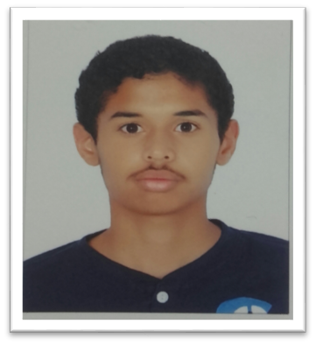

**C.V**

***PERSONAL INFORMATION:***

NAME: Qasim Ebrahim Abdul Husain Jasim Hasan

Personal Number: 001102621

Date of Birth: 8 \11\2000

Nationality: Bahraini

Gender: Male

Marital Status: single

Address: building 4575-Road963-black609

Mobile: 973 32241598_ 973 39177015

Email: [quassimh902@gmail.com](mailto:quassimh902@gmail.com)

**iver**

***ACADEMIC BACKGROUND:***

High school certificate (commercial)-(2015-2018)

***LANGUGES:***

Arabic

English

***Skills:***

Photography

Computer skills

drawing